# Exercises: Polymorphism

This document defines the exercises for ["C# OOP Basics" course @ Software University](https://softuni.bg/trainings/1636/c-sharp-oop-basics-june-2017). Please submit your solutions (source code) of all below described problems in [Judge](https://judge.softuni.bg/Contests/241/Polymorphism-Exercise).

## Vehicles

Write a program that models 2 vehicles (**Car** and **Truck**) and will be able to simulate **driving** and **refueling** them. **Car** and **truck** both have **fuel quantity**, **fuel consumption** **in liters** **per km** and can be **driven given distance** and **refueled with given liters.** But in the summer both vehicles use air conditioner and their **fuel consumption** per km is **increased** by **0.9** liters for the **car** and with **1.6** liters for the **truck**. Also the **truck** has a tiny hole in his tank and when it gets **refueled** it gets only **95%** of given **fuel**. The **car** has no problems when refueling and adds **all given fuel to its tank.** If a vehicle cannot travel the given distance its fuel **does not change.**

Input

* On the first line - information about the car in format {Car {fuel quantity} {liters per km}}
* On the second line – info about the truck in format {Truck {fuel quantity} {liters per km}}
* On the third line - number of commands N that will be given on the next N lines
* On the next N lines – commands in format
* Drive Car {distance}
* Drive Truck {distance}
* Refuel Car {liters}
* Refuel Truck {liters}

Output

After each Drive command print whether the Car/Truck was able to travel the given distance in the formats below. If it’s successful:

Car/Truck travelled {distance} km

Or if it is not:

Car/Truck needs refueling

Finally print the remaining fuel for both car and truck rounded to 2 digits after the floating point in format:

Car: {liters}

Truck: {liters}

### Examples

|  |  |
| --- | --- |
| **Input** | **Output** |
| Car 15 0.3  Truck 100 0.9  4  Drive Car 9  Drive Car 30  Refuel Car 50  Drive Truck 10 | Car travelled 9 km  Car needs refueling  Truck travelled 10 km  Car: 54.20  Truck: 75.00 |
| Car 30.4 0.4  Truck 99.34 0.9  5  Drive Car 500  Drive Car 13.5  Refuel Truck 10.300  Drive Truck 56.2  Refuel Car 100.2 | Car needs refueling  Car travelled 13.5 km  Truck needs refueling  Car: 113.05  Truck: 109.13 |

## Vehicles Extension

Use your solution of the previous task for starting point and add more functionality. Add new vehicle – **Bus**. Now every vehicle has **tank capacity** and fuel quantity **cannot fall** **below 0** (If fuel quantity become less than 0 **print** on the console **“****Fuel must be a positive number”**).

The **car** and the **bus** **cannot be filled up** with **more** fuel **than their tank capacity**. If you **try to put more fuel** in the tank than the **available space,** print on the console **“****Cannot fit fuel in tank”** and **do not add any fuel** in vehicles tank.

Add **new command** for the bus. The **bus** can **drive** **with or without people**. If the bus is driving **with people**, the **air-conditioner** **is turned on** and its **fuel consumption** per kilometer is **increased with 1.4 liters**. If there are **no people in the bus** when driving the air-conditioner is **turned off** and **does not increase** the fuel consumption.

### Input

* On the first three lines you will receive information about the vehicles in format:

**Vehicle {initial fuel quantity} {liters per km} {tank capacity}**

* On fourth line - number of commands N that will be given on the next N lines
* On the next N lines – commands in format
  + Drive Car {distance}
  + Drive Truck {distance}
  + Drive Bus {distance}
  + DriveEmpty Bus {distance}
  + Refuel Car {liters}
  + Refuel Truck {liters}
  + Refuel Bus {liters}

### Output

* After each Drive command print whether the Car/Truck was able to travel given distance in format if it’s successful:

Car/Truck/Bus travelled {distance} km

* Or if it is not:

Car/Truck/Bus needs refueling

* If given fuel is **≤ 0** print **“Fuel must be a positive number”.**
* If given fuel cannot fit in car or bus tank print “Cannot fit in tank”
* Finally print the remaining fuel for both car and truck rounded 2 digits after floating point in format:

Car: {liters}

Truck: {liters}

Bus: {liters}

### Example

|  |  |
| --- | --- |
| **Input** | **Output** |
| Car 30 0.04 70  Truck 100 0.5 300  Bus 40 0.3 150  8  Refuel Car -10  Refuel Truck 0  Refuel Car 10  Refuel Car 300  Drive Bus 10  Refuel Bus 1000  DriveEmpty Bus 100  Refuel Truck 1000 | Fuel must be a positive number  Fuel must be a positive number  Cannot fit fuel in tank  Bus travelled 10 km  Cannot fit fuel in tank  Bus needs refueling  Car: 40.00  Truck: 1050.00  Bus: 23.00 |

## Wild farm

Your task is to create a class hierarchy like in the picture below. All the classes **except** Vegetable, Meat, Mouse, Tiger, Cat & Zebra **should be abstract**. Override method **ToString()**.

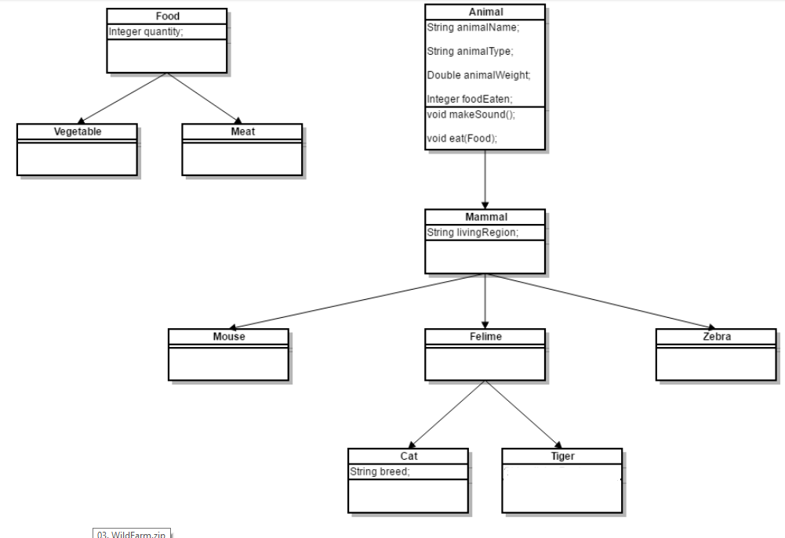

Input should be read from the console. Every **odd** line will contain information about the Animal in following format:

**{AnimalType} {AnimalName} {AnimalWeight} {AnimalLivingRegion} [{CatBreed}** *= Only if its cat***]**

On the **even** lines you will receive information about the food that you should give to the Animal. The line will consist of **FoodType** and **quantity** separated by a whitespace.

**{FoodType} {Quantiy}**

You should build the logic to determine if the animal is going to eat the provided food. The **Mouse** and **Zebra** should check if the food is a **Vegetable**. If it is they will eat it - otherwise you should print a message in the format:

**{****AnimalType in plural} are not eating that type of food!**

**Cats** eat **any** kind of food, but **Tigers** accept **only Meat**. If **Vegetable** is provided to a **Tiger** message like the one above should be printed on the console.

Override **ToString()** method to print the information about the animal in format:

**{AnimalType}[{AnimalName}, {CatBreed}, {AnimalWeight}, {AnimalLivingRegion}, {FoodEaten}]**

After you read information about the Animal and Food then invoke the **MakeSound()** method of the current animal and then feed it. At the end print the whole object and proceed reading information about the next animal/food. The input will continue until you receive “**End**” for animal information.

Sounds produced by the animals:

* **Mouse – “****SQUEEEAAAK!”**
* **Zebra – “Zs”**
* **Cat – “****Meowwww”**
* **Tiger – “****ROAAR!!!”**

### Input

You will receive lines on the Console until the command “End” is received. On every odd line you will be provided with information about an animal. On every even line you will receive the food which is given to the animal.

### Output

For each animal you have read, print two lines on the Console:

* On the first line: the sound produced by the animal
* On the second line: all the information about the animal in the format described above

### Example

|  |  |
| --- | --- |
| **Input** | **Output** |
| Cat Gray 1.1 Home Persian  Vegetable 4  End | Meowwww  Cat[Gray, Persian, 1.1, Home, 4] |
| Tiger Typcho 167.7 Asia  Vegetable 1  End | ROAAR!!!  Tigers are not eating that type of food!  Tiger[Typcho, 167.7, Asia, 0] |
| Zebra Doncho 500 Africa  Vegetable 150  End | Zs  Zebra[Doncho, 500, Africa, 150] |
| Mouse Jerry 0.5 Anywhere  Vegetable 0  End | SQUEEEAAAK!  Mouse[Jerry, 0.5, Anywhere, 0] |